Market Update of Crypto Industry

1. Crypto market hit all time high

* In September, 220 million addresses interacted with a blockchain at least once, a figure that has more than tripled since the end of 2023.
* The explosion of activity is primarily due to Solana, which accounted for about 100 million active addresses. Following were NEAR (with 31 million active addresses), Coinbase’s popular L2 network Base (22 million), Tron (14 million), and Bitcoin (11 million). Of Ethereum Virtual Machine (EVM) chains, the second-most active after Base was Binance’s BNB Chain (10 million), followed by Ethereum (6 million). (Note: EVM chains were de-deduplicated by public key to calculate the 220 million total.)
* After the U.S., the next countries with the greatest share of mobile wallet users include Nigeria (which has sought to provide regulatory clarity including through regulatory incubation programs and has seen significant growth in consumer uses such as bill payments and retail purchases), India (with its booming population and mobile phone adoption), and Argentina (where many residents have flocked to crypto — especially stablecoins — amid currency devaluation).

1. Key in the presidential election and continue to be adored after trump’s election

* Possible movement from the SEC to CFTC under trump that can spur more innovation and development in the crypto space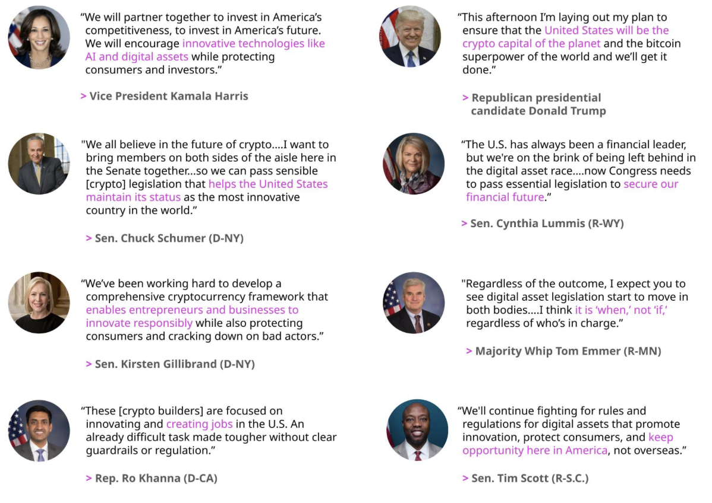

1. Stablecoin has found further product market fit

* Surge in stablecoin adoptions (market cap = 170 billion)

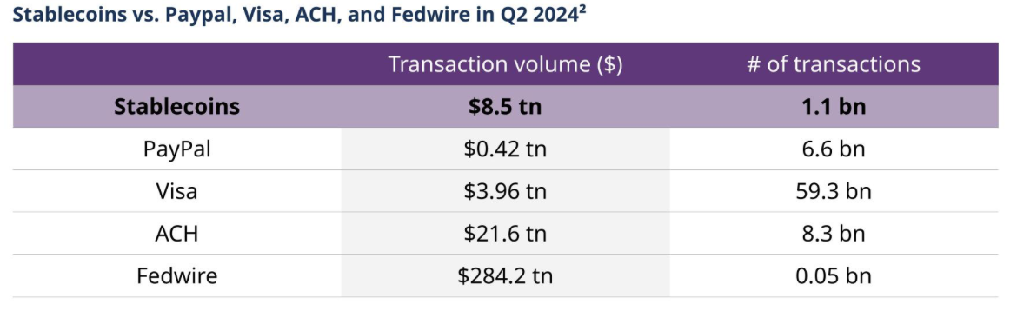

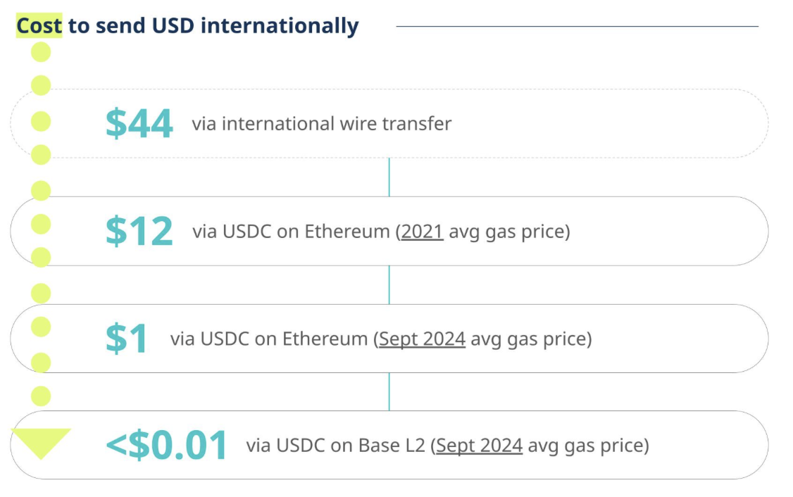

1. Infrastructure improvements have increased capacity and reduced transaction costs

* Blockchains are processing more than 50 times as many transactions per second as they were just four years ago thanks to the rise of Ethereum L2 networks and other high-throughput blockchains

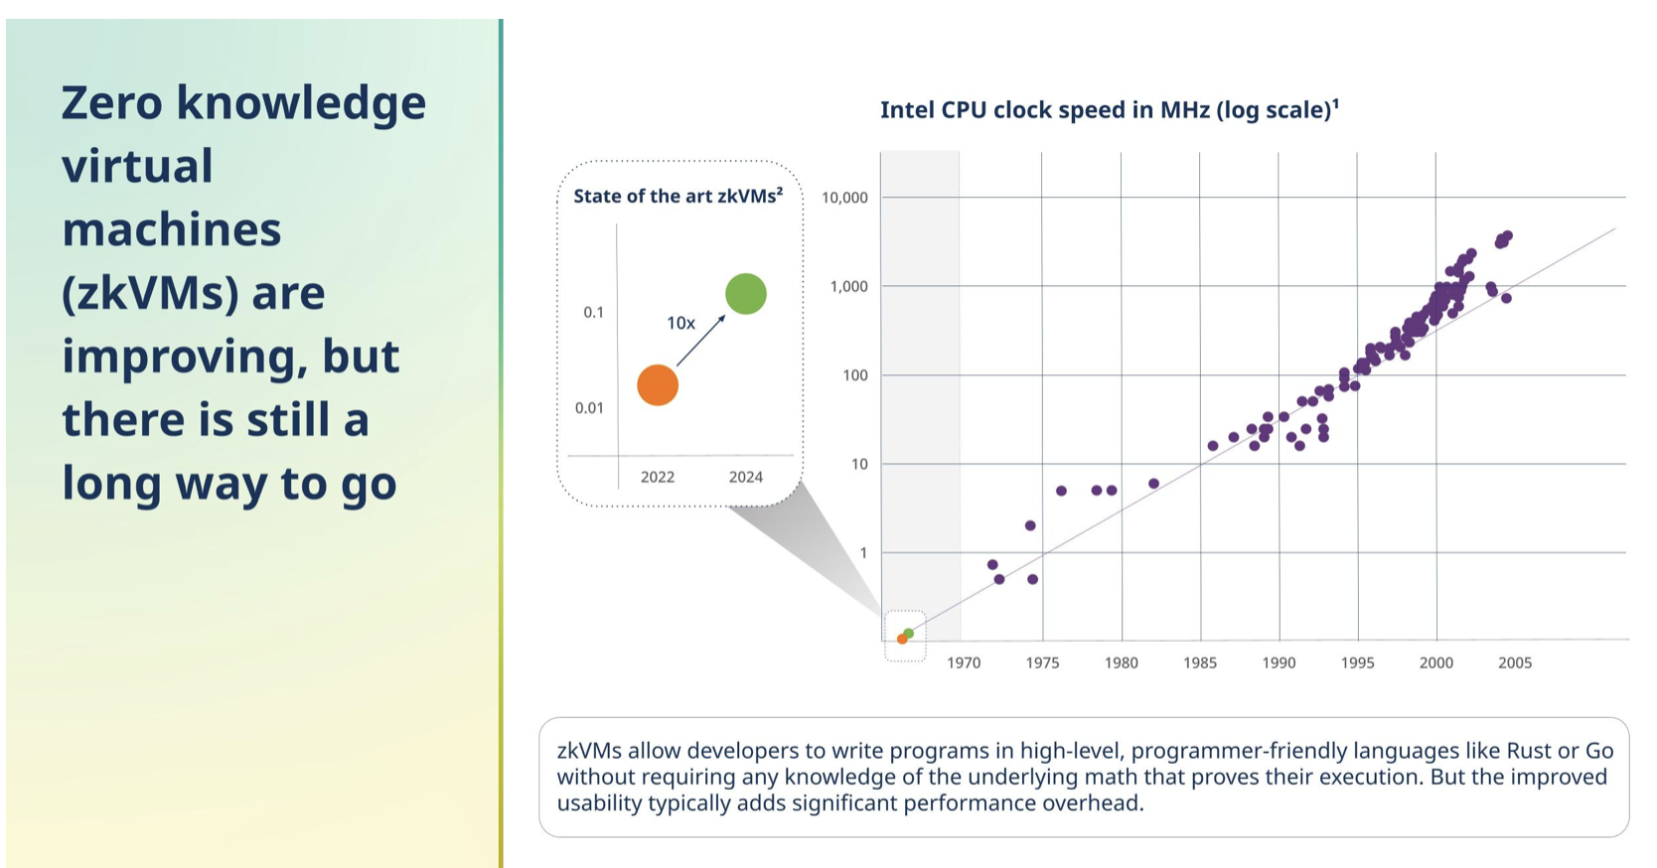

Overall global adoption has risen by approximately 200% compared to prior year 2023 (chainanalysis, 2024). New incoming president donald trump who is well known for his fondness for alternative assets

1. Sui: A high-performance Layer 1 smart contract blockchain offering innovative applications.
2. Bittensor: A platform enabling the development of open and global AI systems.
3. Optimism: An Ethereum scaling solution based on optimistic rollups.
4. Helium: A decentralized wireless network running on Solana and a leader in the decentralized physical infrastructure (DePin) sector.
5. Celo: A mobile first blockchain that is transitioning to an Ethereum Layer 2, focusing on stablecoins and payments.
6. UMA Protocol: An optimistic oracle network offering services to Polymarket, a leading blockchain-based prediction market.

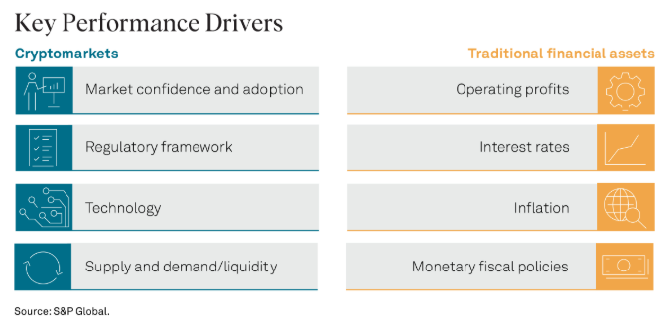

BTC (Emission type: Fixed Supply)

Use case:

A purely peer-to-peer version of electronic cash would allow online payments to be sent directly from one party to another without going through a financial institution. We propose a solution to the double-spending problem using a peer-to-peer network. The network timestamps transactions by hashing them into an ongoing chain of hash-based proof-of-work, forming a record that cannot be changed without redoing the proof-of-work. The longest chain not only serves as proof of the sequence of events witnessed, but proof that it came from the largest pool of CPU power. As long as a majority of CPU power is controlled by nodes that are not cooperating to attack the network, they'll generate the longest chain and outpace attackers. Messages are broadcast on a best effort basis, and nodes can leave and rejoin the network at will, accepting the longest proof-of-work chain as proof of what happened while they were gone.

Founding Team + Backers (Not backed by any foundations):

1. Coinbase: A crypto exchange sponsoring development grant
2. MIT DCI: research organization that provides grants for external developers alongside its own dedicated team of Bitcoin Core developers. However, unlike most of the Bitcoin development sponsors out there, MIT DCI relies on donations to raise funds.
3. Chaincode: New York-based digital currency research organization that contributes to the progress of the Bitcoin network. The platform provides funds to independent Bitcoin developers, in addition to the Bitcoin developers on its permanent team.
4. Square Crypto: Independent research team created by Square with the aim of improving Bitcoin’s open source software. In line with the team’s mission, Square Crypto funds several developers who are working on proposing and implementing upgrades for Bitcoin Core.

Market Confidence & Adoption:

1. Macroeconomic drivers

* Monetary policy around the world has turned less restrictive. Global interest rate cuts led by the federal reserves (0.25% as announced at FOMC November 2024), european central bank & bank of england. M2 money supply has also rebounded back up to the positives with the trend likely going to continue (galaxy, 2024). This means more money available for lending and increased liquidity and likely a fall in interest rates. [This fall in interests makes investors more likely to seek alternative investment pathways with crypto being one of them, & the desire to speculate and earn greater returns from less traditional assets] [+ve]

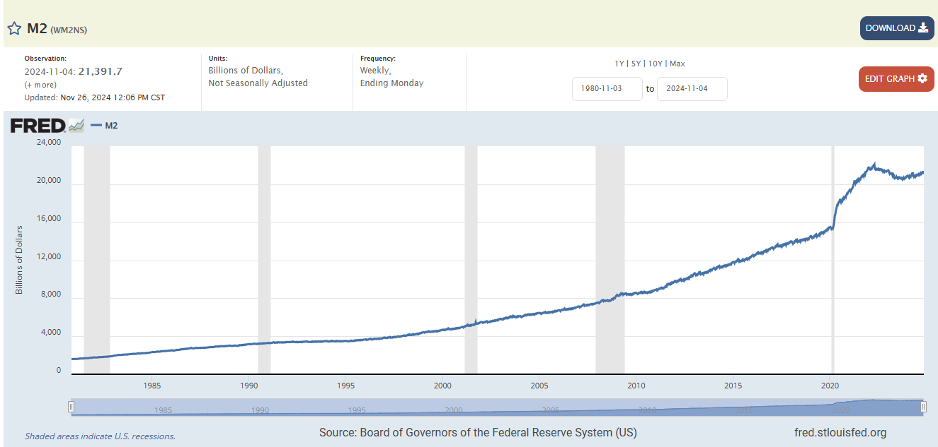

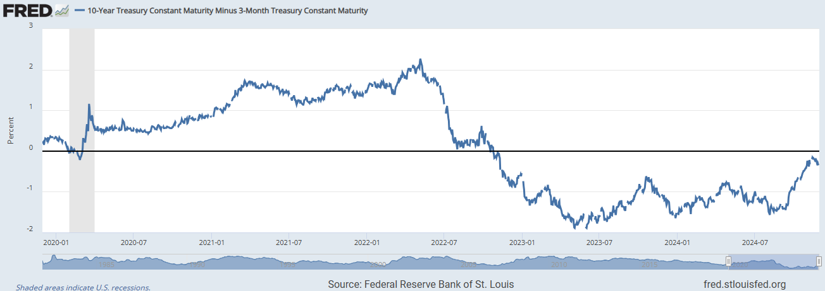

From the 10 year minus 3 month treasury, we can see it moved steadily upwards reaching almost 0 at the current juncture but still being in the negative zone. This implies that long term rates are lower than short term and there still exists some market pessimism though improving. This trend, in my opinion, is due to inflation that was high but tapering off with more grounds to cover. With this, there is still optimism for crypto as an alternative asset but this will likely taper off in the much longer term even as the curve moves back to above 0

Sentiments and perceptions

* Donald Trump’s recent election victory and its intention to move the governing body of cryptocurrencies from the SEC to CFTC, creating a more favourable regulatory framework -> SEC classifies many crypto projects as unregistered securities offerings leading to stricter enforcement and compliance measures. Under the CFTC, development of crypto based products and innovation are less micro-managed (cited against securities laws under SEC) leaving greater room for wallet technology, payment systems etc. [+ve]
* The index incorporates five categories of indicators: credit, equity valuation, funding, safe assets and volatility. Index is positive when stress levels are above average, and negative when stress levels are below average. It has negative impacts on crypto coins and assets when distress is high (very positive). Prices plunged during global financial crisis, COVID, russia’s invasion of ukraine

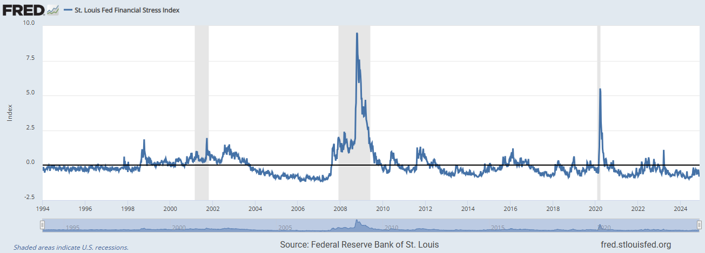

* Increased global competition over resources, world’s reserve currency status and BRICS intention to potentially create a new reserve currency moving away from the dollar. These have intensified the urgency to secure more alternative assets as their own -> hash rates have gone up exponentially with over 70% introduced since start of 2022 (e.g. Trump pushing for more btc to be mined and belonging to the americans) [+ve]
* Early January 2024 saw the approval of Bitcoin ETF -> This saw a jump in mining activities past 3 months after the announcement where 14 largest US listed miners traded more than 230% their proportional share of the 4 year block reward compared to average of 143% in 2022 [+ve]

Regulatory Framework:

1. April 17 saw senator Lummis and Gillibrand proposing a bipartisan bill for stablecoin framework which requires stablecoin issuers hold a one-to-one reserves and safeguards such as FDIC involvement in the event of failure of algorithmic stablecoins (grayscale, 04/2024) [+ve]
2. Markets in crypto-assets regulation (MiCA) in the EU have effectively established new strong AML and consumer protection rules, requires service providers to obtain licenses and stricter oversight on firms [-ve]
3. The Financial Conduct Authority (FCA) in the UK introduced “cooling off” period measures, a 24hr wait between request to purchase and the actual purchase for new buyers. FCA roadmap as follows: (Q1/Q2 2025 Trading platform rules including access, matching and transparency requirements / Intermediation rules for order handling and execution requirements / Lending rules including ownership, access and disclosures / Prudential consideration for crypto asset exposure) + (Q4 2025 Conduct and firm standards for all regulated activities -> Consumer duty / Complaints / Conduct) + (2026 All policy statements published) (fca, 2024) [-ve]
4. Asia: Singapore emphasizes on reserve requirements for stablecoins and operational transparency but has seen many new exchanges getting in principle approval for their operations in Singapore. More recently, BTC ETF is not allowed to be listed in the country unlike the US / China maintains a permanent ban on cryptocurrency like bitcoin / Japan’s Financial Services Agency tightens law to prevent domestic crypto asset to be transferred out of country in case foreign exchanges go under like the case of FTX [+ve/-ve]

Supply / Demand & Liquidity

Demand Factors:

1. **Right:**

The ownership of bitcoin allows one to participate in the broader Bitcoin network without any intermediaries, ensuring full ownership of their funds. The right come in the form of community based voting and here are some notable decisions:

1. *Segregated Witness (SegWit) (2017):*
   * A soft fork upgrade aimed at scaling Bitcoin and fixing transaction malleability.
   * Outcome: Increased transaction capacity and facilitated the development of the Lightning Network. -> 100% of miners between blocks 477,792 to 479,807 voted for this resolution
2. *Taproot Upgrade (2021):*
   * Enhanced privacy and scalability by introducing Schnorr signatures and more efficient transaction execution.
   * Adoption: Over 90% miners voted for this resolution
   * *Block Size Debate and Bitcoin Forks:*
   * Governance conflicts over scalability (e.g., block size limits) led to hard forks like Bitcoin Cash (BCH) in 2017.
   * These debates highlight Bitcoin’s decentralized governance model, where consensus is reached through user and miner alignment.
3. *Lightning Network Adoption:*
   * A layer-2 solution supported by the community to address transaction speed and cost challenges.
   * The network's success reflects grassroots support and developer coordination.

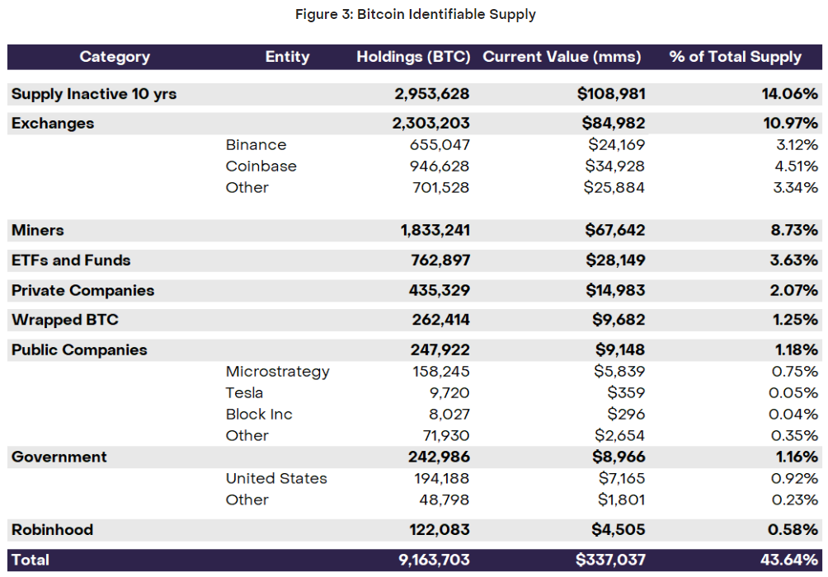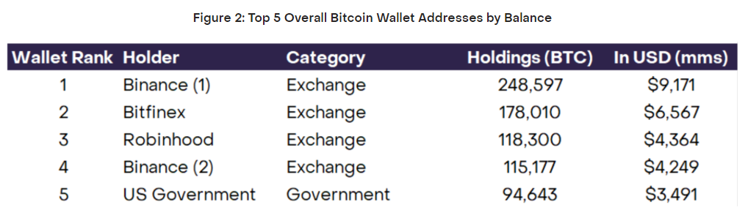

From the figures above, we see that the majority vote is likely to lie in trusted organizations such as the US government when it comes to decision making on the future roadmap of BTC. Not to mention the strong backing by a slew of organizations on its development such as MIT, chaincode and so on. [+ve]

1. **Value Exchange:**

* Most popular alternative currency for buying and selling goods and services worldwide thus far due to first mover advantage. [+ve]
* BTC utilizes Proof-Of-Work mechanism to incentivize miners with actual btc tokens that can be used for voting, staking on wrapped BTC platforms and so on. This value however is dwindling due to the reduced block tokens that can be mined down into the future [-ve]

1. **Currency:**

* Payment unit in both retail and institutional settings. The adoption rate of crypto currency has increased by over 200% from 2023 to 2024 and the trend is likely to continue (chainanalysis site research, 2024)
* Enables low-friction, borderless transactions compared to traditional banking systems.
* With new, improved Layer 2 solutions like the Lightning Network in the future, Bitcoin achieves even faster and cheaper transactions, enhancing its utility as a currency. [+ve]

1. **Earnings:**

* Users can create passive income by participating in Bitcoin lending platforms, DeFi projects built on Bitcoin derivatives, or through staking in wrapped BTC protocols -> upcoming new projects include photon labs allowing staking and market neutral trading, babylonchain to help validate proof of stake blockchains and earn returns and many more / new fungible standards of BRC-20 and Runes and a whole host of layer 2 and scaling growth, advent of ordinals and inscriptions increased expressivity allowing users to create and trade digital artifacts or bitcoin NFTs [+ve] (<https://www.sygnum.com/blog/2024/07/30/defi-on-bitcoin/>)
* Scarcity Effect: Bitcoin’s fixed supply and halving events (cutting mining rewards every 4 years) generate long-term scarcity, indirectly benefiting holders through price appreciation over time.

Supply Factors:

1. **Allocations:**

* Founder Allocation: 1 million BTC (~4.76% of supply) in the pseudonymous creator’s hands. The holdings are viewed as dormant
* Private Investors: No private sale. Early adopters earned them through the POW mining consensus
* Public Sale: First made public in 2009 its genesis block
* Foundation / ecosystem allocation: No foundation control but supported by independent organizations and entities
* Other Supply considerations: 20-25% of btc supply are estimated lost due to forgotten keys, lost wallets and also HODLers who lock them in cold storage / dormant wallets.

1. **Vesting Period:**

* No vesting period nor lock ups for bitcoin. All supply stemmed from the POW consensus mechanism.

1. **Emissions:**

* Current Market Cap / FDV = 0.94. A close to 1 ratio likely implies that inflationary pressures are not high for bitcoin.
* Supply cap of 21M, emission type = fixed supply, no burn mechanism